**Static Code Analysis**

This section will guide you to:

* Configure a Jenkins build job to poll an SCM nightly
* Configure a Jenkins build job to perform static code analysis with SonarQube

**Step 1:** Creating a Git repository for the FreshMart project

* Log in to your Github account.
* Click on the plus icon next to the profile picture and select *New repository* from the drop-down menu.

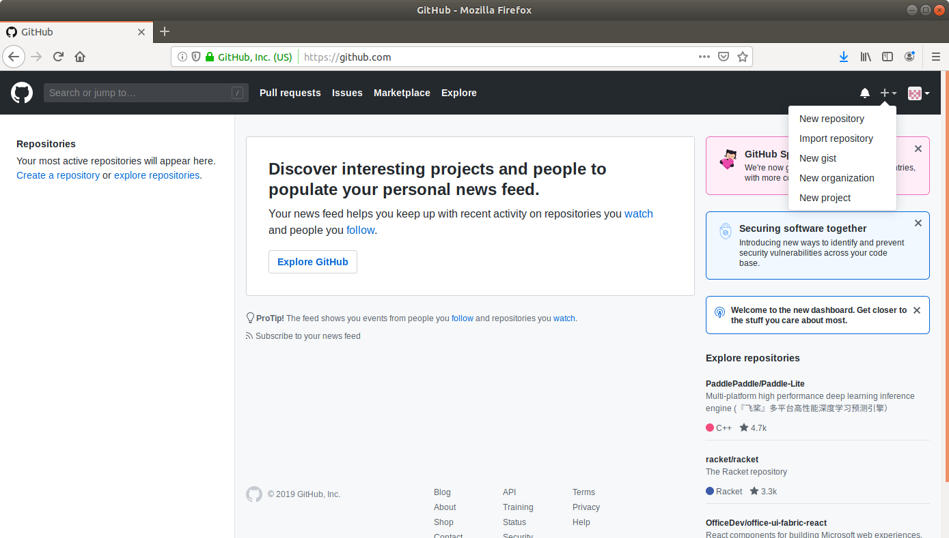

* Fill the required fields in the Create Repository form.

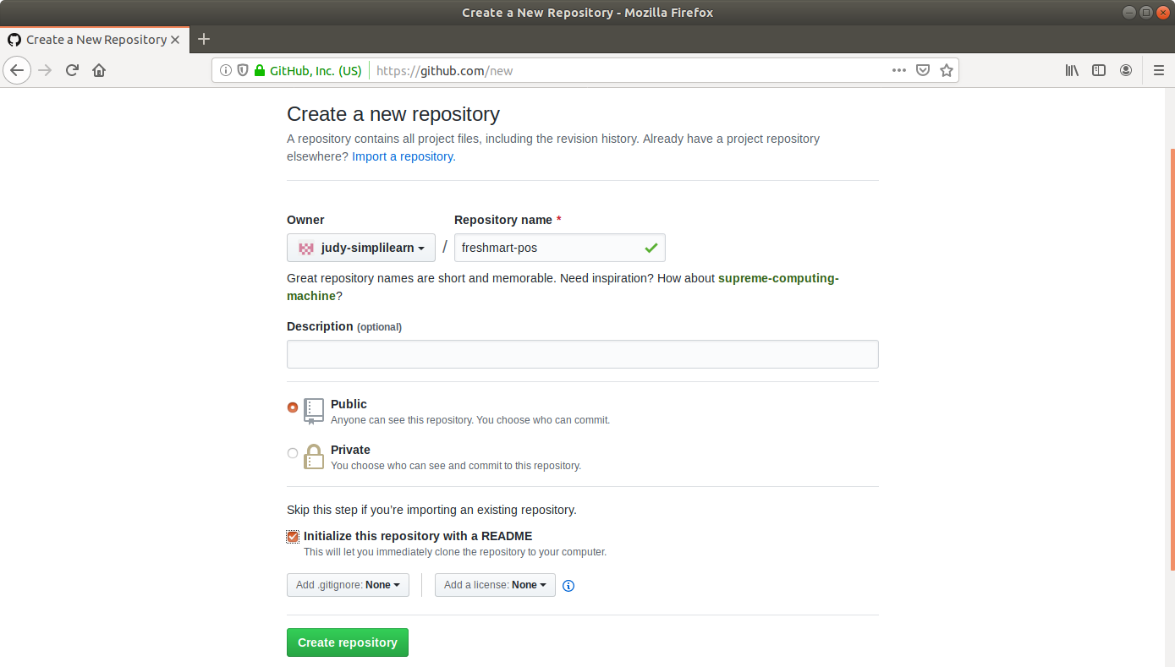

* Click on the **Create Repository** button.
* Click on the **Clone or download** button and copy the URL.

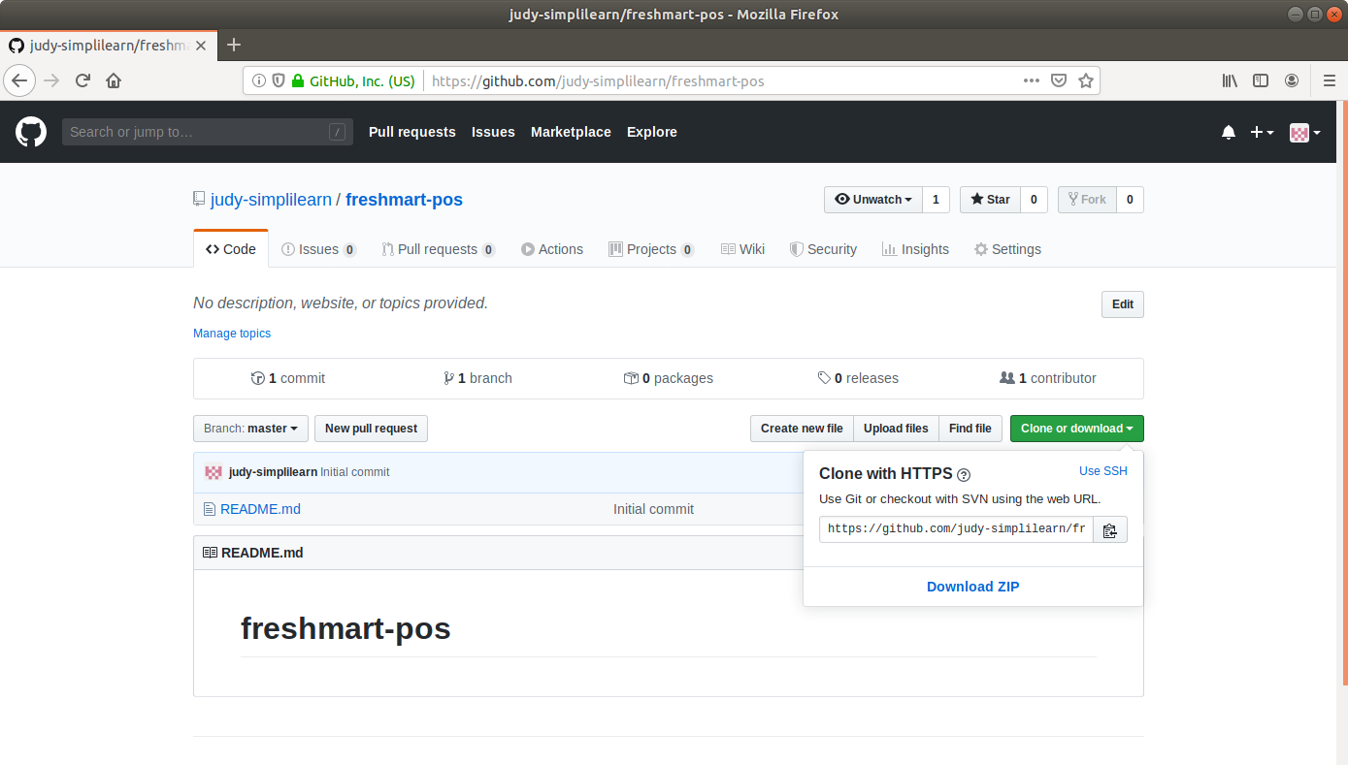

**Step 2:** Generating a spring boot project

* Go to ​start.​spring.​io/​

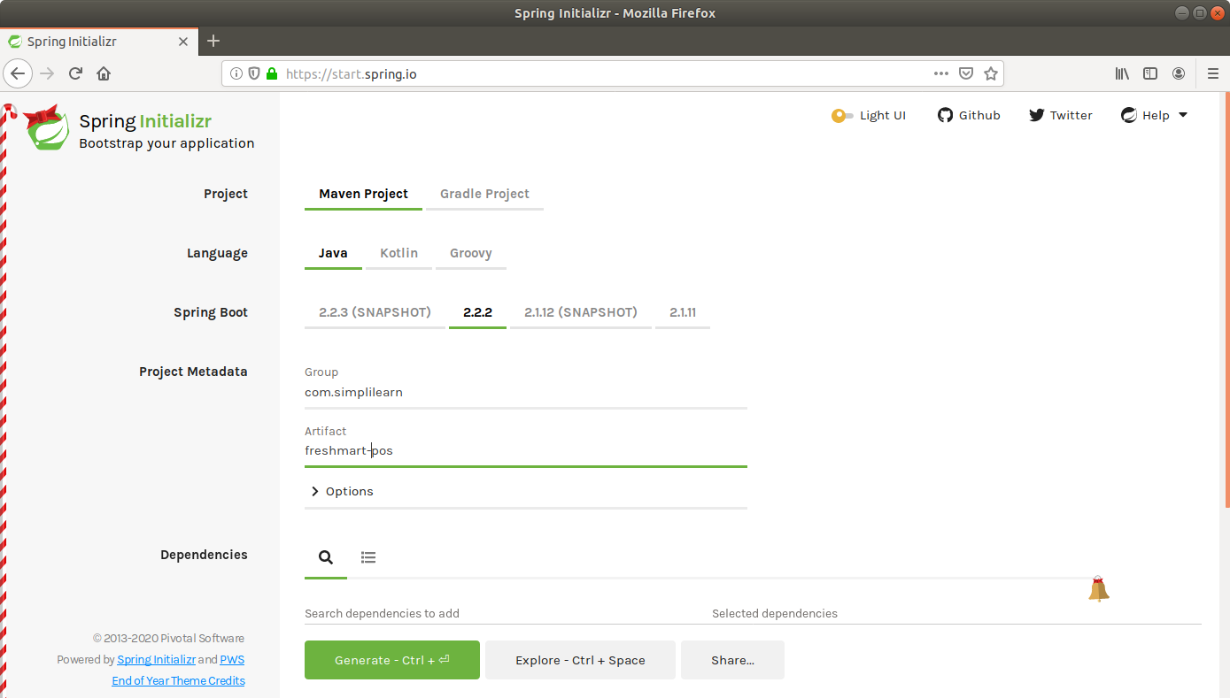

* Select Maven as the project type.
* Fill Group and Artifact with appropriate values. For example, *com.simplilearn* and *freshmart-pos.*
* Click on **Generate Project.**
* The generated skeleton project should be downloaded as a zip file.

**Step 3:** Committing the project skeleton to the repository

* Open the terminal and navigate to an appropriate location.
* Run **git clone [URL]** to clone the repository.
* Unzip the downloaded spring boot project to the cloned repository.
* Commit the changes to the remote SCM.
* Run **git add .**
* Run **git commit -m "Add project skeleton"**
* Run **git push -u origin master**

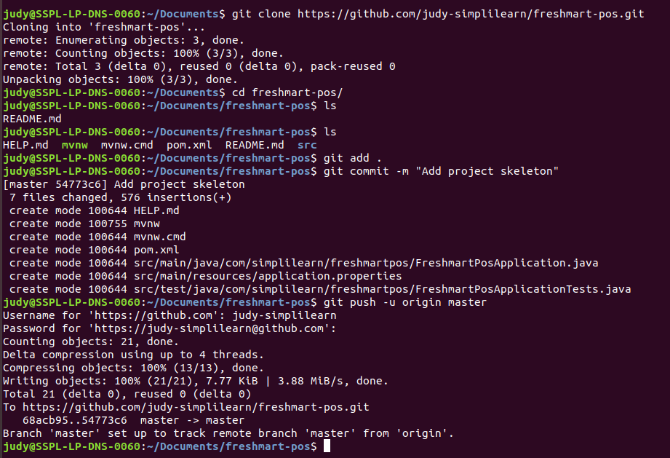

**Step 4:** Creating a build pipeline in Jenkins

* Ensure SonarQube is running at localhost:9000
* Install the SonarQube Scanner plugin on Jenkins
* Generate a user token on SonarQube
* Integrate SonarQube with Jenkins
* Create a .properties file at any location and enter the following content to the file:

***sonar.projectKey=github-jenkins-sonar***

***sonar.sources=./src***

* This file contains certain sonar properties, like which folder to scan, which folder to exclude in scanning, and what is the project key.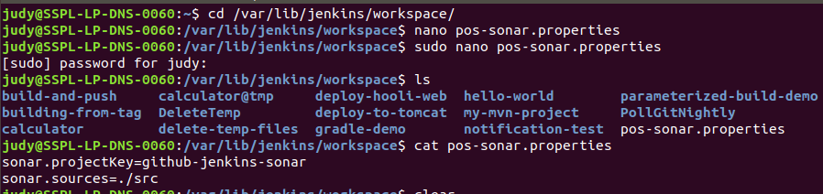
* Go to Jenkins dashboard.
* Click on *New Item*.
* Enter a name for your build job.
* Select *Maven Project* as the build job type.

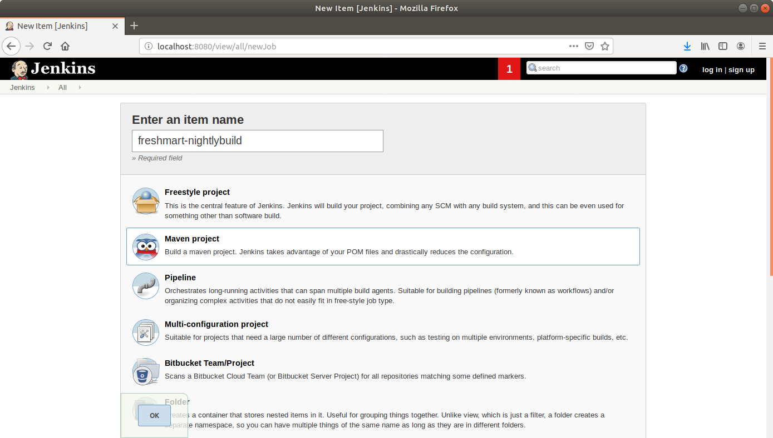

* Click OK.
* Select *Git in SCM.*
* Add the repository URL.

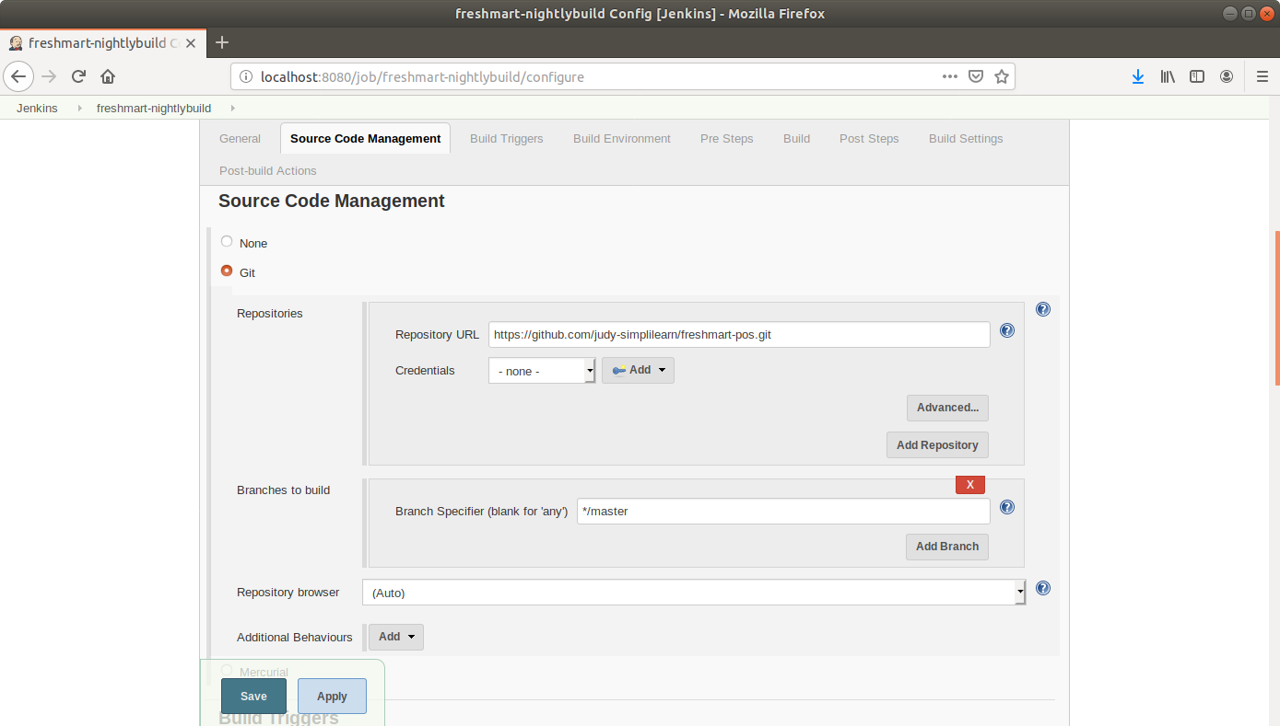

* Select *Poll SCM in Build Triggers.*
* Schedule the build to run every night.

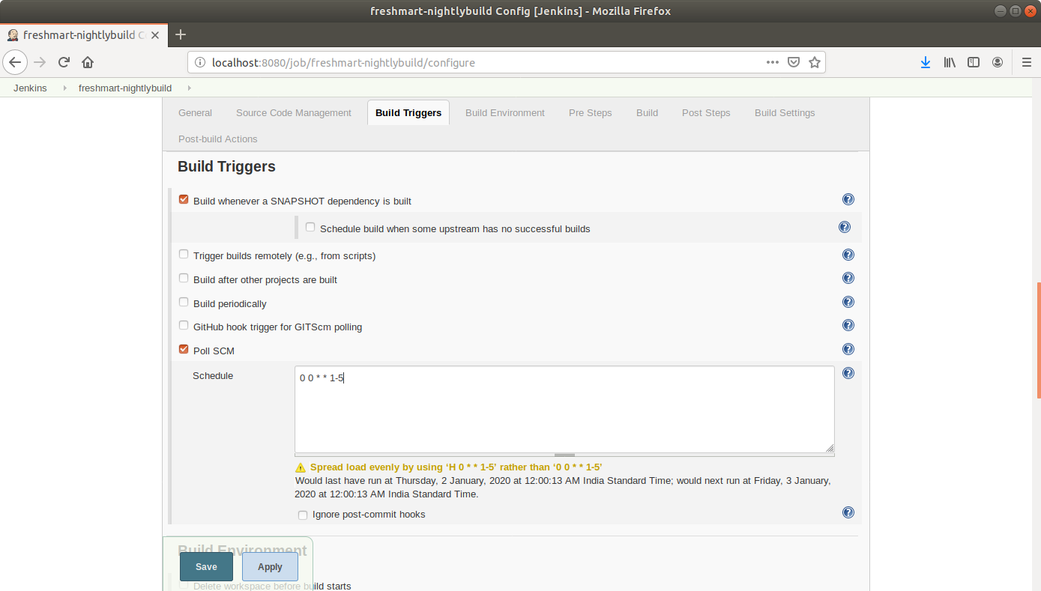

* Scroll to *Pre Steps* and click on *Execute SonarQube Scanner.*

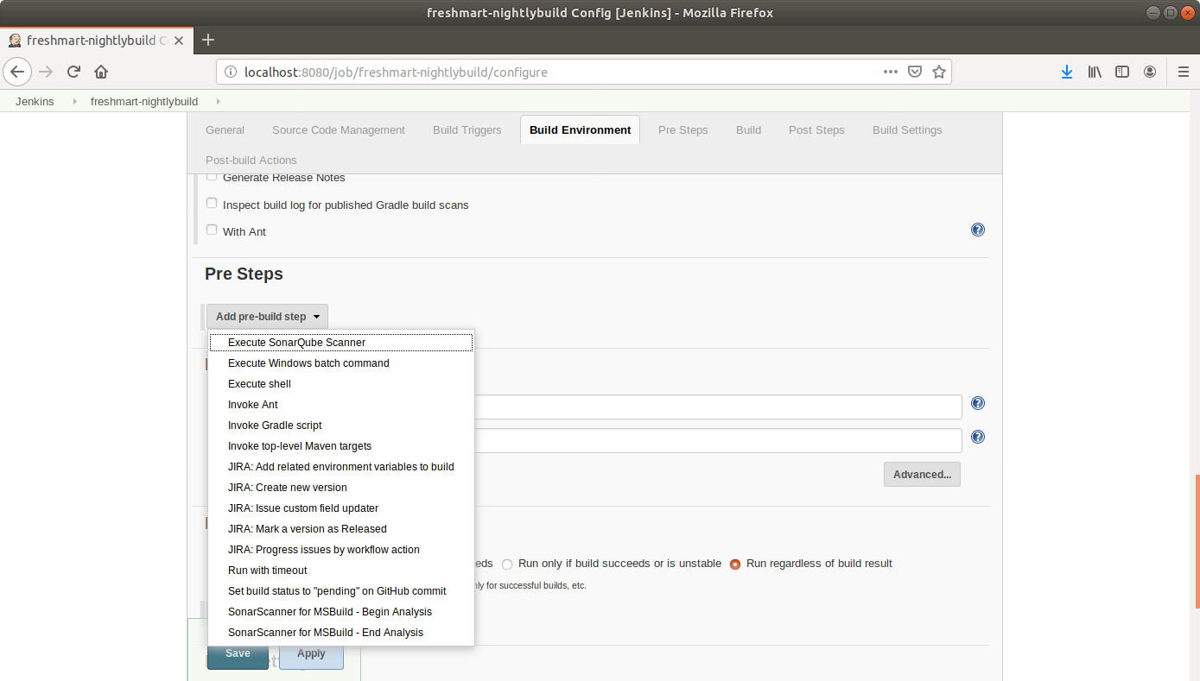

* Provide the path to the .properties file.
* Click Save.

**Step 5:** Running a build job in Jenkins

* Click on *Build Now* in the project window.
* Jenkins will now build your job and output the logs.